honda is a Kalamazoo native and the funeral coordinator at Galilee Baptist
Church. She is the sole owner of Hurd’s Tax and Administrative Services since
2014, where the company provides tax preparation and administrative
services such as: bookkeeping, notary and assisting seniors with budgeting
and completing forms. Ms. Hurd (soon to be Mrs. Buchanan August 2022) is
a retired trustee and head administrative assistant for the Galilee Baptist
Church for 6 years. As a retired administrative assistant, she has been in the
administrative field for over 40 + years. She has worked for the Federal Home
Bank of Atlanta where she served 10 years, Bank of America, Comerica Bank,
and Eaton Corporation – where she started her administrative career. Her
passion is cooking, organizing events with family and friends, traveling, and
making new friends
honda is a Kalamazoo native and the funeral coordinator at Galilee Baptist
Church. She is the sole owner of Hurd’s Tax and Administrative Services since
2014, where the company provides tax preparation and administrative
services such as: bookkeeping, notary and assisting seniors with budgeting
and completing forms. Ms. Hurd (soon to be Mrs. Buchanan August 2022) is
a retired trustee and head administrative assistant for the Galilee Baptist
Church for 6 years. As a retired administrative assistant, she has been in the
administrative field for over 40 + years. She has worked for the Federal Home
Bank of Atlanta where she served 10 years, Bank of America, Comerica Bank,
and Eaton Corporation – where she started her administrative career. Her
passion is cooking, organizing events with family and friends, traveling, and
making new friends
honda is a Kalamazoo native and the funeral coordinator at Galilee Baptist
Church. She is the sole owner of Hurd’s Tax and Administrative Services since
2014, where the company provides tax preparation and administrative
services such as: bookkeeping, notary and assisting seniors with budgeting
and completing forms. Ms. Hurd (soon to be Mrs. Buchanan August 2022) is
a retired trustee and head administrative assistant for the Galilee Baptist
Church for 6 years. As a retired administrative assistant, she has been in the
administrative field for over 40 + years. She has worked for the Federal Home
Bank of Atlanta where she served 10 years, Bank of America, Comerica Bank,
and Eaton Corporation – where she started her administrative career. Her
passion is cooking, organizing events with family and friends, traveling, and
making new friends
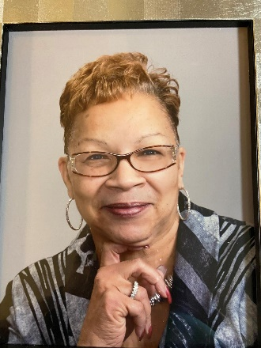
Rhonda is a Kalamazoo native and sole owner of Hurd’s Tax and Administrative Services since 2014, where the company provides tax preparation and administrative services such as: bookkeeping, notary and assisting seniors with budgeting and completing forms. Mrs. Buchanan is a retired trustee and was head administrative assistant for the Galilee Baptist Church for 6 years. As a retired administrative assistant, she has been in the administrative field for over 45+ years. She has worked for the Federal Home Bank of Atlanta where she served 10 years, Bank of America, Comerica Bank, and Eaton Corporation – where she started her administrative career. Her passion is cooking, organizing events with family and friends, traveling, and making new friends.

